Oxford City Council’s
Community Centres Strategy
2016-2020

Bringing communities together:
Skills, Health & Life

Executive Summary

Oxford City Council is fortunate in having retained an extensive network of community centres across the city. They differ widely in their size, range of activities hosted and their physical condition. This strategy is designed to initiate a process for the long term management of the network and the support structures provided by the Council. The centres represent collectively a substantial investment by the Council in community managed facilities and the Council’s strategic objective is to support them to be active and inclusive places. This helps to bring communities together, and achieve the wider objectives of improving skills, reducing inequalities and creating strong and active communities.

This strategy has been written using the evidence of a needs assessment (included in section six) that was undertaken by SLC consultants and through consultation with a steering group made up of representatives from the voluntary sector, the Federation of Community Associations, councillors and senior council officers. The strategy identifies ways in which the Council will support the development of the Community Centre network and prioritise its resources to extend and improve the ways in which the centres can serve their communities.

The strategy classifies facilities in three tiers (shown in section seven). The top tier are community hubs which are multi-functional community facilities, the next tier are smaller community centres, or community halls with the final tier being rooms for hire, either owned by the Council or other organisations.

The strategy identifies eight priority themes, four under each of two action areas:
Improving Facilities and Sustainable Management.

Improving Facilities

- Establish Rose Hill as a vibrant, inclusive community hub.
- Draw up development plans for the Blackbird Leys and Barton Community Centres aimed at widening and improving the range of functions and activities which they offer, and securing effective community involvement in the management of these centres.
- Work with the Reference Group to extend and improve the range of activities offered at the East Oxford Community Centre, and to consider the results of the feasibility study into its future physical shape and functions.
- Develop a prioritised maintenance plan for all centres with a five year time horizon.

Sustainable management

- Review ways in which those centres that are currently managed by the City Council can be effectively managed in future on a long term and stable basis with strong community involvement.
- Review the current lease arrangements for each centre and place on a long term stable basis.
- Support Associations in developing management skills and expertise and in recruiting volunteers to run the centres’ activities.
- Support Associations to recruit and retain trustees and manage their buildings.

1. Setting the scene - Why do we need a Community Centre Strategy?

The Council owns 18 community centres and there are 300 other facilities across the City offering community space. Most of the community centres are well managed by Community Associations, these Associations are essential for many community centres and their work is greatly valued by the Council. A Community Association is a voluntary group formed by members of the public who want to improve the quality of life in their neighbourhood; this has led to them managing community centres. They are registered charities accountable to the Charities Commission for meeting their declared charitable objectives.

The Associations have increasingly become bogged down dealing with increasingly complex health and safety and building management issues. This leaves less time for the Associations to develop new activities, promote the centres, or work with organisations such as health services. The strategy focusses on finding new ways of supporting Community Associations such as in the recruitment, training and retention of trustees and also in building management.

Many of the buildings are old and require increasing levels of maintenance. Across the centres there is around £1.7 million of backlog maintenance, although this figure reduces with Rose Hill being replaced and other potential developments. While there is a commitment to invest and undertake this work, continued government cuts to the Council’s budget mean it will be increasingly difficult to meet these costs. The strategy explains what changes we need to make to prevent an inevitable decline in community centres and to support the valuable work they provide in a changing and ever demanding world.

There is also a focus on ensuring each centre has an appropriate legal agreement in place. Robust legal agreements for tenants are essential to ensure health and safety requirements are met, for Associations to obtain external funding and to give the public confidence that its assets are being managed in the best interests of the communities they serve.

The Council operates services across the city and focuses its resources where there are the highest levels of social deprivation. The Council is committed to reducing these inequalities by providing high quality, vibrant community hubs offering a broad programme of activities in the largest priority areas of Blackbird Leys, Barton and Rose Hill.

These ambitions are made more difficult by continued cuts to the Council’s budget from government and national policy changes that significantly impact on the Council’s ability to deliver services.

2. What the strategy covers?

- Our plans for the City’s community centres
- How we will make community facilities more accessible
- Creating a sustainable management model
- Our approach to working with communities

3. Where the strategy fits?

The Corporate Plan is the overarching plan for the Council; this strategy supports the following areas of the Corporate Plan:

Strong, Active Communities

Community centres deliver broad benefits that help to create strong, active communities.
They provide activities for all ages, and provide places where people can go to meet,
eat, attend courses and activities.

By improving the centres, we will help to encourage more and a broader range of people
to use them, helping to encourage community cohesion, reduce health inequalities and
issues such as the isolation of some older people.

Vibrant, Sustainable Economy

Oxford is a thriving city and in 2014, was awarded City Deal status. The result of this award will lead to further investment into roads and public transport, specifically tailored to link universities with the city’s major industrial and research areas. Within all such developments, ensuring good community facilities is a key ingredient.

Cleaner, Greener Oxford

The Council is committed to minimizing the carbon created from its activities. The new centre at Rose Hill has incorporated a range of low carbon technologies such as solar panels to generate energy. All the development work within the strategy will incorporate the best possible low carbon approach.

Efficient, Effective Council

The Council is willing to invest in community facilities where there is a strong business case both in financial terms and in terms of outcomes. The operation of the other community centres in the city is efficient and effective where there is robust governance of the centre, its legal status is clear and it is well maintained.

Through the leases it develops, the Council will clarify the relative responsibilities of Community Associations and the Council with respect to each of its community centres. Having developed a mutually agreed set of criteria for the ‘effectiveness’ of a community centre in collaboration with community associations, the Council will continue to work with them to maintain that effectiveness. The Council will, through its directly-run ‘Tier 1’ community centres lead by example.

4. The Oxford context

Demography

In common with many cities, there are major inequalities in Oxford. The Index of Deprivation 2015 ranks Oxford 166 out of 326, just barely placing it in the bottom half of the most deprived local authority areas in England.

People living in the least deprived areas of the city can expect to live around seven years longer than people living in the most deprived areas.

10 of Oxford’s 83 ‘Super Output Areas’ are amongst the 20% most deprived areas in England. These areas, which are located in the Leys, Littlemore, Rose Hill and Barton areas of the city, experience multiple levels of deprivation - low skills, low incomes and relatively high levels of crime.

Around 23% of Oxford’s under 16s live in low-income households and child poverty is a key concern in eight neighbourhoods which feature among the 10% worst affected in England.
In 2013, Oxford’s 'usual resident population' was estimated to be 155,000. The City's population grew by 12% over the decade 2003-2013 and is projected to continue to grow rapidly, reaching 165,000 by 2023.
Oxford is ethnically and internationally diverse. In 2013, 28% of Oxford's residents had been born outside the UK and an estimated 4,000 short-term international migrants were visiting the city. These factors, combined with large student numbers, create an incredibly transient population. This means that effectively communicating what’s available in the city is even more important.
Health

Oxford exhibits a range of health inequalities, with the headline challenges being:
- The majority of Oxford’s population remain inactive
- Life expectancy is 7.7 years lower for men in the most deprived areas of Oxford compared to the least deprived areas
- The health cost of inactivity in Oxford is £2.1 million per year.
- 17,855 people in the Oxford City GP locality registered with depression
- Mental health issues among the older population are very often directly linked to isolation and loneliness. Nationally 18% of people felt lonely always, often or some of the time

Figure 1 - Index of Multiple Deprivation 2015
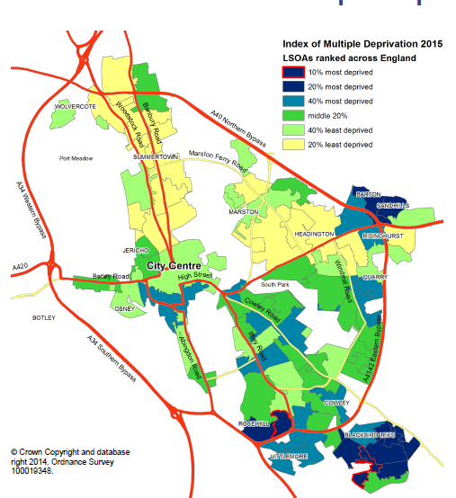
Super Output Areas ranked across England
Source: Department of Communities and Local Government

National context

These increasing physical and mental health problems are placing significant challenges on public services. This is happening alongside further cuts to health and children’s services with valuable resources such as children’s centres due to close.

This means that the role of community centres has seldom been more important as they are well placed to help tackle these broad community needs.

5. Where we are now?

The Council’s ambition is to deliver world class services. The main challenges and
opportunities for community centres are that:

  - The majority of Oxford’s population do not use, enter or engage with their local community centre
  - Systems and procedures are not effectively shared with centres often competing for users
  - There is minimal performance data and no agreed measures of what constitutes “success”
  - The Council invests around £1million on community centres
  - Many of the buildings are of a poor quality and there is a £1.7 million maintenance backlog
  - Associations struggle to recruit and retain trustees
  - The basis for occupation for many is uncertain with some holding over on expired leases and others on outdated licences

As Council budgets continue to reduce we need to look for new and more effective ways to run services and support community groups to best support the communities they serve. While all services differ, a good example is where the Council invested £14.5 million of capital into leisure centres to transform the quality. This led to usage increasing by 40% (mainly in the subsidised target groups such as older people and children) and revenue costs reducing by £2 million a year, there is no maintenance backlog and usage continues to increase. This poses the challenge of how can we get the community centres onto the same upward virtuous circle.

The c£1 million that the Council invests each year on community centres is made up from c£442,000 of direct costs (repairs and maintenance, waste and service charges and the support the Council commissions from Oxfordshire Community and Voluntary Action) additional to these direct costs there are also c£557,000 of opportunity costs (subsidised rental income that the Council would otherwise be entitled to and Council Officer time).

Even with these issues, the community centres still provide around 20,000 activity sessions each year. This demonstrates the vast potential and community benefits that can be attained by improving the current offering.

6. How we have developed the strategy

A steering group was set up to support the development of this strategy. The group
Included The CEO of Oxfordshire Community and Voluntary Action, the Chair and
Deputy Chair of The Federation of Community Associations, the Board member for
Stronger Communities and opposition Spokespersons along with senior Council
Officers.

Consultants were commissioned to undertake a geographic and demographic analysis of community centres using a Geographic Information System. They applied a 15 minute walk time catchment for each centre. The catchment is based on a judgement of how far Oxford residents can reasonably be expected to travel to access community centre provision. This has been overlain with ward boundaries, and the 2015 Index of Multiple Deprivation (IMD) ratings of each lower super output area (LSOA).

A methodology was devised to objectively assess each centre and its impact on the community in terms of providing accessible coverage in strategic areas of importance.

Community Centre ANALYSIS - DISTRIBUTION, CATCHMENT & IMPACT
1 | Barton Neighbourhood Centre | 15 | Regal Community Centre
2 | Blackbird Leys Community Centre | 16 | Risinghurst Community Centre
3 | Bullingdon Community Centre | 17 | Rose Hill Community Centre
4 | Cheney Community Centre | 18 | South Oxford Community Centre
5 | Cutteslowe Community Centre | 19 | Wood Farm Community Centre
6 | Donnington Community Centre | 20 | The Asian Cultural Centre
7 | East Oxford Community Centre | 21 | East Oxford Games Hall
8 | Florence Park Community Centre | 22 | West Oxford Community Centre
9 | Headington Community Centre | 23 | St Margaret’s Institute
10 | Jericho St Barnabas Community Centre | 24 | The Barn
11 | Jubilee 77 Community Centre | 25 | Barns Road Community Rooms
12 | Littlemore Community Centre | 26 | Mortimer Hall Marston
13 | North Oxford Community Centre | 27 | Littlemore Village Hall
14 | Northway Community Centre and Sports Centre (considered together for the purposes of this study) | 28 | St Luke’s

Key
 | Not owned by OCC |  | Owned by OCC
Table 1 – community centre key

The below insights map shows where the city’s community centres are in relation to areas of deprivation.
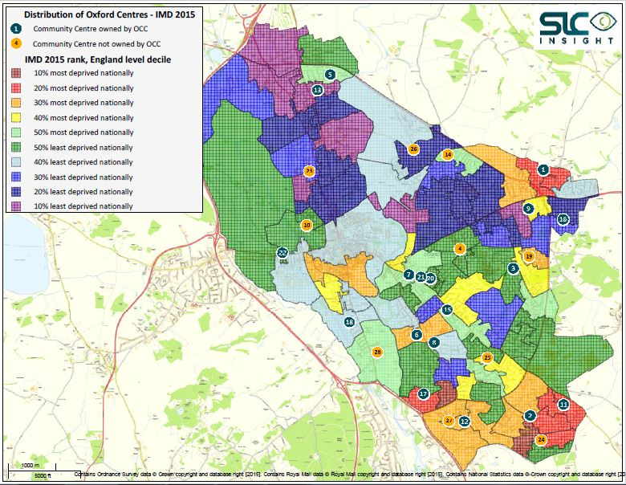 Figure 2 – location of community centres in relation to deprivation
Figure three shows the density of community centres using the 15 minute walk time. This map highlights the opportunity to combine the East Oxford Games Hall with East Oxford Community Centre to create an improved quality community hub.

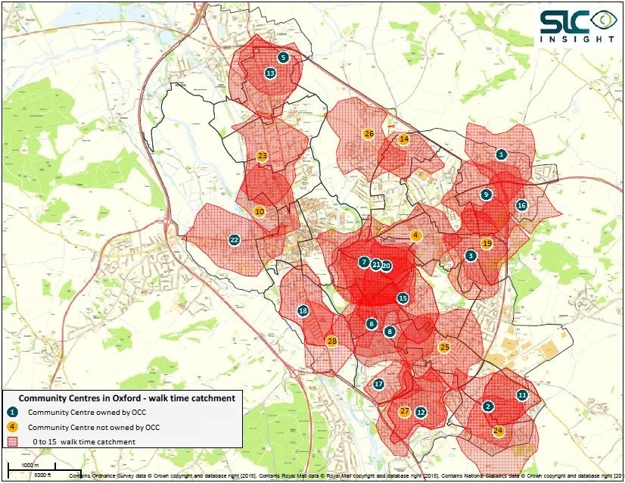
Figure 3 – community centre catchment areas

The final insights map takes the three tiers of provision (hubs, community halls and community rooms) to show the varying levels of community facilities across the city. As you would expect Oxford’s city centre has a large number of tier three facilities. It also shows gaps in community facilities in parts of Blackbird Leys, Marston and Churchill. This does not mean that the Council should try to build new facilities as the City is very well provided for as a whole. It does mean that planning decisions must take this into account and increased efforts made to ensure that people are aware of which local facilities are accessible.

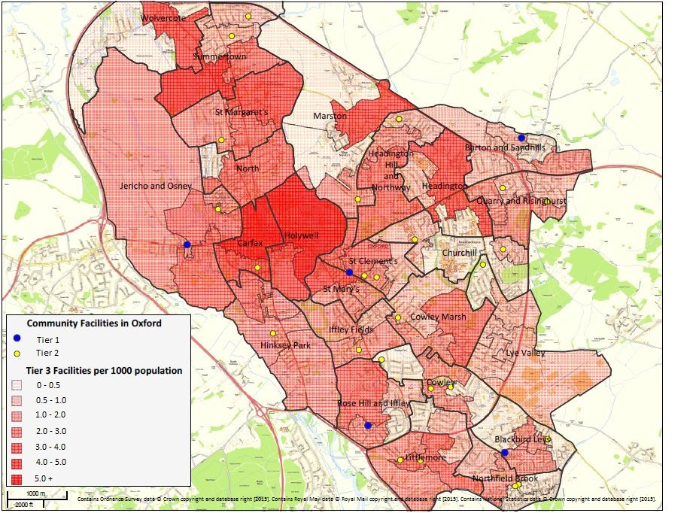
Figure 4 – the density of all three tiers of community provision

Centres and Areas of Strategic Importance

There are a number of centres which, from the perspective of their location and catchment area, serve an area of strategic importance in terms of relative deprivation levels which would otherwise not fall within the catchment of any other centre. The facilities which exclusively serve significant areas of LSOAs within the 0%-20% most deprived nationally are shown below
Ref | Name | Reason
1 | Barton Neighbourhood Centre | Serves an area of Barton & Sandhills within 10%-20% most deprived nationally
2 | Blackbird Leys Community Centre | Serves an area of Northfield Brook within 10%-20% most deprived nationally
11 | Jubilee 77 Community Centre | Serves an area of Blackbird Leys within 10%-20% most deprived nationally.
14 | The Barn | Serves an area of Northfield Brook within 0%-10% most deprived nationally and an area of Blackbird Leys within 10%-20% most deprived nationally
17 | Rose Hill Community Centre | Serves an area of Rose Hill & Iffley within 10%-20% most deprived nationally
Table 2 - Centres of strategic importance

This evidence is combined with the Council’s priorities and local knowledge to create our plans. The community hubs are in the main the closest facilities to these areas which supports the need to ensure these hubs are high quality and have a wider appeal.

7. Our plans

Objective One – our investment plans

The Council is determined to ensure that there are inclusive, high quality community hubs in the below areas. It is investing £4.7 million in a flagship facility at Rose Hill, spending £200,000 to explore options to improve East Oxford and has money within its corporate repair and maintenance budget to keep others in a reasonable condition.

In line with other Council assets, investment will be prioritised into centres where there is the greatest social need and where the centre has robust governance and a long term lease in place. Investment is also dependent on the approval of the Capital Programme which is agreed as part of the annual budget process.

The strategy enables developer contributions to be effectively allocated against need and there is the possibility that some of the works can be superseded if improvement schemes can be found that attract external funding.

Tier one - Community Hubs

The Council manages Blackbird Leys, the new multi-functional hub at Rose Hill and plays a role in the management of Barton Community Centres. West and South Oxford Community Centres are already operating as community hubs and provide a diverse and well managed community offering.

Centre | Improvements | Notes
Blackbird Leys | A high quality replacement centre is included within district centre re development plans | The community centre has a maintenance backlog of £290,000.
Barton | Improve and expand the health provision  Explore ways to improve the sense of arrival  and flow of the centre | £200,000 developer contribution
East Oxford | Create a high quality community hub | £200,000 for feasibility work  The scheme currently has no budget and needs to be financed from capital receipts  The centre has a backlog of £225,000
Rose Hill | New build opens January 2016 | £4.7 million
South Oxford | Support the Community Association to create a Community Café. | £50,000  Maintenance backlog of £120,000.  Explore external funding options for the café and wider improvement opportunities.
West Oxford | Maintain in good condition | Minimal backlog
Table 3 – community hubs

Tier two – Council owned community halls

In addition to the relatively small number of community hubs there are a larger number of purpose built community centres, or community halls. These works will be funded from the Council’s corporate maintenance budget and be prioritised alongside other Council assets. We will explore opportunities as they arise to join provision together in a way that protects the valuable community outcomes the centres deliver and improves the sustainability of the centres.

Tier three– rooms for hire (any ownership)

The final part of the community offer are rooms for hire such as church halls and rooms in schools. Objective three shows how we will better join up the three tiers of provision that make up the offer to make it easier for residents to access community facilities.

Objective Two – improved management

While facility condition is important, it is the people and activities that make community centres places that people want to visit. They need to be inviting, well managed and easy to access.

Leases

The leases of the city’s community centres need attention. For a number of them, the contractual term of their lease has elapsed and the associations are “holding over” under the terms of that lease. Some centres do not have a lease, but what is known as a licence to operate the building. This means they have few rights and no security of tenure. Leases not only enable the building occupier to have a clear relationship with the Council as the building owner, they are also essential if Associations are to obtain external funding which will be increasingly important as Council budget reduces.

The Council is taking two approaches reflecting the current legal position of Associations.

For those Associations who currently have a lease with security of tenure under the 1954 Landlord and Tenant Act we will undertake individual negotiations to agree how they can best meet the needs of their local communities. This applies to West Oxford, Bullingdon, Florence Park, Headington and Risinghurst.

All other Associations will be offered 25 year leases outside the security of tenure protection offered by the 1954 Landlord and Tenant Act.

Should any Association fail to meet their agreed objectives then the Council will work with the Association to support it to improve, although ultimately non-performance would lead to the possible forfeiture of the lease.

Council managed centres

The Council’s preferred position is that robust, sustainable community organisations manage the centres. A consultant’s report in 2014 found that there would be operational improvements and efficiencies gained by joining the Council run centres into a single trust. There may also be benefits from such a model for Association managed centres as they could choose to buy services such as caretaking, cleaning, ICT system or bid writing. These benefits are not exclusive to a trust model and we will explore various options to see if there is a better way to ensure the centres currently managed by the Council can meet the needs of the communities they serve.

Volunteers

People volunteer for a variety of reasons. Many people want to gain experience, meet new people, acquire new skills, or use volunteering as a way to get a new job or start a career. Others just want to give back to their community, to help a friend or promote a worthwhile activity. Volunteers are essential for community centres. The Community Federation have asked for more support in attracting and developing volunteers for their Associations. This will be realised by placing increased focus on the work that the Council commissions from Oxfordshire Community and Voluntary Action to support volunteers.

Service quality

The Council will introduce customer feedback cards at the centres it manages and undertake an annual survey with individuals who do not use the centres to find out what we could change to make them want to use the centres.

We will undertake monthly quality audits of Council run centres and develop improvement plans. Quality will be also be checked by introducing an external quality assurance system (ISO 9001). Centres that are managed by Community Associations will be encouraged and supported to implement a continuous improvement plan. These plans will clearly vary for a large facility compared to small community halls that may need a light touch.

Objective Three – improved community access

While the Council delivers services across the city, it focuses its work in communities where there is the greatest need. We have four Locality Officers supporting Blackbird Leys, Rose Hill, Barton, Littlemore, Northway, Wood Farm and Cutteslowe. Their role is to support the delivery of the top priorities that have been agreed with local councillors for each area and coordinate the Council’s resources within these areas to support Councillors and work with partners to quickly resolve issues. The Locality Team also help local people know what facilities are available to them and help community groups find suitable venues. The Locality Officers are based in community centres half of their working week so they can help to make the centres the heart of the community. They will support staff working in the centres with community engagement and outreach.

Oxford’s transient population means that a large number of people will not be aware of what community spaces are available and others, for a range of reasons, will either not want to access them or feel that the community centre is not for them. The Council will take an active role in promoting the community offer and targeting promotions at underrepresented groups. One way this will be fulfilled is by having an improved website that promotes not only community hubs and community halls but also community rooms.

The strategy recognises that people now expect to be able to book services online. The Council will introduce an online booking and payment system at the centres it manages. This has the additional benefit of enabling usage data and will help us to market the centres. We will explore how the usage of the system can be extended to help people book community halls and community rooms.

This data and improved customer feedback also helps to inform what activities are provided and at what times.

6. Demonstrating the difference

We will develop a manageable number of measures that will help us to track the
success of the strategy. The below are measures we will use in Council managed
centres and in collaboration with the Community Associations we will seek to develop a
mutually agreed set of measures for the centres managed by Associations. Where more
data is needed to be able to set measures we will use the first year of the strategy
establish the baseline.
Ref | Measure | 2015/16 | 2016/17 | 2020 target
CC1 | Usage of our community centres | Establish base line | 20% increase | 20% increase
CC2 | Number of sessions in our community centres | c22,000 | 25,000 | 30,000
CC3 | Number of sessions targeting health improvement | Establish base line | Increase by 5% | Increase by 5%
CC4 | Number of sessions supporting targeting improving skills | Establish base line | Increase by 5% | Increase by 5%
CC5 | Income at Council managed centres | Establish base line | Increase by 5% | Increase by 20%
CC6 | Social impact of our community centres | Establish base line | Increase by 5% | Increase by 5%
CC7 | Revenue cost to the Council of community centres | £190k direct costs | Reduce by 10% | Reduce by 20%
CC8 | Number of volunteers in our community centres | Establish base line | Increase by 5% | Increase by 5%
CC9 | Satisfaction levels | Establish base line | >85% | >85%
Table 4 – measures

The final section of the strategy demonstrates how we will achieve the eight priorities.

Priority 1 –Rose Hill…an exemplar Community Hub
What do we want to achieve? | How are we going to do it? | Milestones | When by | Who | Resources
A well-used centre | Excellent promotion of the centre | Marketing plan implemented | Jan 2015 | General Manager / Commercial Manager | £6,000 year one  Then £2,000 per year
Inclusive usage | A diverse programme of activities | Quarterly programme reviews | 2015 to 2020 | General Manager | Officer time
Financially sustainable | Annual review of fees and charges linked to budgeting process | Review every September | Annually | General Manager | Officer time
High levels of satisfaction | A motivated and well trained team  Obtain feedback from 20 users every month  Regular facility audits  Implement a quality management system | Training plan implemented  Commence  In place  In place | Jan 2016  2016 onward  2016  2016 | General Manager  Duty Officer  Performance Manager  Performance Manager | £2,000  Officer time  Officer time  £1,000

Priority 2 –Improve Blackbird Leys & Barton Community Centres
What do we want to achieve? | How are we going to do it? | Milestones | When by | Who | Resources
BARTON
Improved health offering at Barton | Support the expansion of the GP surgery at the centre | Plan developed  Works complete | 2016  2019 | Assets Manager | £200,000 developer contribution
Improve the sense of arrival and flow of the building | Review previous schemes and develop an integrated and costed plan | Cost the scheme  Implement the scheme | April 2016  Dec 2016 | Assets Manager  General Manager | Explore funding options
BLACKBIRD LEYS
A new Community Hub | Develop as part of the district centre development | Appointment of Delivery Partner  Develop brief for community hub  Hub opens | Jan 2016  Dec 2016  Summer 2019 | Regeneration Project Sponsor  Assets Manager  Partnership &Regeneration Manager  Partnership & Regeneration Manager | Officer time  The costs are still being developed and funding would need to be allocated

Priority 3 – Improve East Oxford Community Centre
What do we want to achieve? | How are we going to do it? | Milestones | When by | Who | Resources
Develop an affordable scheme | Consolidate existing community facilities to promote energy efficiency and reduced operational costs | Feasibility study finalised  Progress project if viable | Jan 2016  Sept 2016 | Head of Service | £200,000  Finance to be raised by joining provision onto one site, external grants and through the Council’s capital programme
Increased usage and satisfaction | Representative community reference group  Increase satisfaction levels | Continue to develop the group  Measure satisfaction | 2016  Jan 2016 onwards | Head of Service / Asset Manager  Centre coordinator | Officer time  Officer time

Priority 4 –Prioritised maintenance
What do we want to achieve? | How are we going to do it? | Milestones | When by | Who | Resources
Tackle the maintenance backlog | Prioritise funds  Support community associations to obtain external funding so improvement opportunities can be combined with maintenance works | Develop schemes of work  Meet community associations to talk though opportunities | Once a lease is in place  April 2016 | Head of Service/ Asset Manager  Active Communities Manager | Part of the Council’s corporate maintenance plan  Office time

Priority 5 – Sustainable, effective management
What do we want to achieve? | How are we going to do it? | Milestones | When by | Who | Resources
A sustainable, high quality delivery model for the centres the Council currently owns | Asses the financial viability differing management models and the scope of services that could be included | Complete feasibility report | April 2016 | Head of Service | £12,000  Officer time
Improved systems | Robust consistent operating systems in place for Council manage centres  Improved quality | New system in place  All Council managed community hubs quality assured | March 2016  2017 | Active Communities Manager  Performance Manager | Officer time  £3,000
A joined up community offer | Promote the community offer on the website  Review arrangements to support building management at centres operated by Community Associations | Improve web content for Council managed centre  All community spaces promoted on the same website  Reviews undertaken | March 2016  2017  2016 the annually | Communities Support Officer  Communities Support Officer  Performance Manager | Office time  Officer time  Officer time

Priority 6 - Appropriate lease arrangements
What do we want to achieve? | How are we going to do it? | Milestones |  | When by | Who |  | Resources
All centres have leases in place | Implement two lease types:  Protected lease – negotiate terms with Associations  An unprotected lease – standard terms with a breakage clause. | All centres on one of these lease | November 2017 |  |  | Head of Service |  | Office time

Priority 7 –Volunteers
What do we want to achieve? | How are we going to do it? | Milestones | When by | Who | Resources
Increased numbers, representatives and quality of volunteers in community centres | Improve how opportunities are promoted  Increase the focus in the work the Council commissions OCVA to do to support volunteers  Improved training for volunteers  Develop a shared database of volunteers | Changes in place  Update the 2016/17 service agreement  As above  Audit | Spring 2016  Jan 2016  Jan 2016  Autumn 2016 | Active Communities Manager  Grants officer  OCVA  OCVA | Officer time  Commissioning budget of £49,000  As above  As above

Priority 8 - Trustee recruitment and development
What do we want to achieve? | How are we going to do it? | Milestones | When by | Who | Resources
More, better trained and more diverse trustees | Work with partner organisations to better coordinate the recruitment and training of trustees  Review and refocus the OCVA commission | Working partnership in place  Update the 2016/17 service agreement | April 2016  Jan 2016 | Communities  Manager  Communities  Manager | Officer time  Commissioning budget of £49,000

DOH: Public Health Observatories – Oxford Health Profile 2014 http://www.apho.org.uk/resource/view.aspx?RID=50215&SEARCH=oxford&SPEAR
Department of Health – Be active Be Healthy, 2006/07, measure: cost of inactivity
Oxfordshire Mind’s 2013 Community Mapping report
The Needs Analysis for Older People in Oxford.
Community Life Survey: England, 2013 to 2014 Statistical Bulletin, July 2014. Crown Copyright 2014

